Home Page

Why Choose Us?
Are you tired of ineffective marketing campaigns that fail to deliver results? At Sparkle Media, we believe in using data-driven strategies and creative thinking to drive real success for our clients. With a team of experienced professionals and a proven track record of success, we are confident that we can help your business reach its goals.
Up for the challenge? Reach out to us!

What We Do
To help businesses of all sizes succeed in the digital world by being the one stop destination for all your digital needs

About Us
We are a digital marketing startup dedicated to helping businesses of all sizes succeed in the online world.
Our team of experienced professionals has a passion for all things digital, and we are constantly staying up-to-date on the latest trends and techniques to ensure that our clients are always ahead of the curve.
We offer a full range of digital, creative & tech services, from photography and branding to digital marketing and upto website & software development 'this sentence can be changed as per the services or how we want to showcase'. Our goal is to help businesses like yours get noticed online, attract more customers, and drive growth.
We believe that every business is unique, and we take the time to get to know your business and your goals before crafting a customized marketing strategy that delivers results.
We look forward to the opportunity to work with you and help your business thrive.

Values
- data-driven
- adaptability
- collaboration/partnership
- integrity

Vision

Mission
to help businesses of all sizes and nature succeed in the digital world

Our Approach
Research
A digital marketing specialist will always research your competitors as well as your customers to produce better content.

Assess
The competitors' and your brand's current situation needs to be assessed to have a thorough understanding of what needs to be done and what needs to be avoided.

Strategize
Then a well-structured strategy needs to be sketched out, with risks analyzed in all aspects and contingency plans ready.

Implement
And it is a matter of kick-starting an exemplary digital journey for your brand in an extraordinary way.

Our Services
DIGITAL LAB
Content Marketing
Create content that advertise your brand with a story!
Content marketing is one of the trickiest areas.
This is where your brand’s entire marketing relies on. From social media contents, website contents, blog, search engine headlines to everything that represents your brand from voice to visual. Everything is content and that content needs to be top notch if you expect people to stop, engage and convert!
Content Strategists of Sparkle Media have expertise in creating contents that converts and retains the audience in any platform!
Let’s look at the type of content we can create for you!

Social Media Content-
Creating quality social media content is like ordering a complete meal.
The right text, perfect design, top notch captions with converting CTAs and well planned hashtag strategy has to be blended all in one. And our team of experts will help you build and develop your social media presence.
Click here to talk more about social media. redirect to social media page
Website and Landing Page Content-
Website and Landing pages play the same role in your game of digital marketing.
Create web content that helps your audience to easily find you with high quality SEO, then understand and engage with your brand.
Website or Landing Page is a place where you can monitor your consumer/audience behavior in-depth.
Excited to know more about website development?
Click here! redirect to web dev
Blogs and Articles-
Give something for the audience if you expect them to come back to you!
Provide those resourceful blogs and articles that attract them towards your website or social media pages, make them retain in the site consuming the content they have been looking for.
If you want your brand to keep your audience educated and engaged. Then you know what to do next.
Get the perfect and well-toned blogs and articles written by the experts at Sparkle Media.
Vlogs-
Visualized content that consumes less effort of the audience has the highest interaction levels.
And we create videos with the 3 second challenge, that your first 3 seconds of the video will be irresistible and trigger the audience to watch the entire video.
Our team has expertise in video script creation, ideating it and doing the video production till the very end ensuring your needs are met beyond your expectations.
Click here to know more about our Photography and Videography services. redirect to photography & videography

Social Media Marketing
We help you choose the right platforms and target the right audience on Social Media!
Unleash your brand with Social Media Marketing.
Social media is an ever-changing landscape with altering algorithms and topical trends; to keep your competitive edge, you must prioritize your social media management strategy to keep your competitive edge.
Do you see your social media as just an administrative task? Do you often scramble to put a post together at the last minute after realizing you haven’t posted in a few weeks?
Perhaps no matter what you post, you can’t seem to achieve the results you want to see?
If you are looking for a more strategic approach and one that delivers results, we can help.
Check out our Social Media Packages:
Bronze | Silver | Gold | Platinum | Customized Package
6 Static posts (Resizing will be charged additionally) | 12 Static posts (Resizing will be charged additionally) | 21 Static posts (Free Resizing) | 32 Static posts (Free Resizing) | We do understand the need for a customized package.  Let's pick the best for your brand.  Should you wish to handpick the necessary services?  Get in touch with us right away!
Content Scheduling | 2 social media channels | 2 - 4 social media channels (Including GoogleMyBusiness -Best for SEO) | 2 - 5 social media channels (Including GoogleMyBusiness -Best for SEO)
Community Management (Partial) | Monthly updated Facebook cover photo (FREE) | Monthly updated Facebook cover photo (FREE) | Monthly updated Facebook cover photo (FREE)
Tier 3 Designer | Hashtag Strategy and Research (Every 3 month) | Hashtag Strategy and Research (Every month) | Hashtag Strategy and Research (Every month)
Content languages (English, Sinhala and Tamil) | Competitor Analysis | Competitor Analysis | Competitor Analysis
 | Updated Social Media Strategy every 12 month | Updated Social Media Strategy every 6 month | Updated Social Media Strategy every 3 month
 | Monthly analysis report | Monthly analysis report | Monthly analysis report
 | Community Management (9am to 6pm) | Community Management (9am to 6pm) | Community Management (9am to 6pm)
 | Tier 2 Designer | TikTok Account Set Up | TikTok Account Set Up
 | Content languages (English, Sinhala and Tamil) | 4 TikTok videos per month (Basic) | 8 TikTok videos per month (Basic)
 |  | Tier 1 Designer | Tier 1 Designer
 |  | Content languages (English, Sinhala and Tamil) | Content languages (English, Sinhala and Tamil)
ADD UP + | ADD UP + | ADD UP + | ADD UP +
* Monthly analysis report - LKR 7000 | * 1 FREE Blog Article - 500-700 words | * 20 sec animation video - LKR 10,000 | * 20 sec animation video - LKR 10,000
 | * Paid Media Management - LKR 5000 | * 30 sec animation video - LKR 12,000 | * 30 sec animation video - LKR 12,000
 | * 20 sec animation video - LKR 10,000 | * FREE Paid Media Management | * FREE Paid Media Management
 | * 30 sec animation video - LKR 12,000 | * 1 FREE Blog Article - 800-1000 words | * 1 FREE Blog Article - 800-1000 words
Test your Social Media Performance! | Build your brand community and brand awareness! | A journey of a never ending creativity to your brand and engagement with your audience.
LKR 27,000 | LKR 59,000 | LKR 98,000 | LKR 164,000

· Get to Know Your User
Our agency creates accessible, interactive material that engages your audience in addition to keeping an eye on and managing your social media community.
· Consistency is Key
We provide consistent content by using calendars and scheduled scheduling. Regular blogging posting helps your audience recognise your brand's voice and message, which creates an impactful relationship with them.
· Reporting and Analysis
Our skilled social media managers will routinely assess performance and plan fresh approaches to boost performance and account growth.

Paid Media Management
Lack of patience? Wanna rush results on social media?
Let’s boost the post and speed of growth!
Social media advertising is a smart way to grow your business and generate leads. With a diverse range of platforms to target all ages, paid social provides a unique and extremely in-depth way of targeting that no other marketing channel can provide.
How do we do it?
· Data-driven social strategy
Using a data-led approach we determine the right audiences and platforms which align with your business objectives. Our finessed audience selection process taps into a world of new opportunities to give you a competitive edge.
· Campaign alignment
We seamlessly fit our paid social strategy into your wider digital strategy for a fully integrated campaign. Sometimes this means running seasonal promotion-led campaign bursts, and other times it may be an always-on awareness message to grow brand visibility.
· Ad copy and creative
By understanding your objectives and assigning the relevant platforms for your campaign, we select the best ad types for optimum performance. From carousels to video ads, we do it all, including creative design and carefully crafted copy.

What can we do for you?
· Facebooks Ads
· Instagram Ads
· Twitter Ads
· LinkedIn Ads
· Pinterest Ads
· TikTok Ads
· Setting up or Overhaul Social Media Ad Accounts
· Audience Targeting Research
· Facebook Pixels and Catalog Management
· Conversion Tracking
· Ad Creative and Copy

Search Engine Optimisation
Be Found and Visible on Search Engines!
Why do you need SEO?
68% of online experience starts from search engine
53.3% of website traffic are organic traffic
92.9% of traffic is generated by Google Search, Images and Maps

We do full-on-full SEO for your website or pick the one you like!
ON-PAGE OPTIMISATION
The content on your website pages must match the intent and expectations of users so Google ranks your page high in the search. We’ll create unique content and make expert optimisations to drive new traffic and clicks.
TECHNICAL SEO
There are hundreds of elements that fall under a technical SEO remit from site speed to re-directs. We’ll identify and fix the technical elements of your site to give you a solid SEO foundation for further growth
MEDIA PLACEMENTS & LINKS
High-quality links from reputable sources will increase the trust of your brand in the eyes of Google and your target audience. We’ll secure authority-boosting placements to generate impressions, clicks and online sales.

Type of SEO you can pick:
E-Commerce SEO
E-commerce SEO will bring in the right leads who have a direct interest in your brand. Save time and money by targeting a specific niche!
Local SEO
People often look for services around them that are more convenient for them. Even if you provide service globally you can still attract visitors by being available to them on the local search results.

Search Engine Marketing
Appear on your interested and intended audiences search!
Here’s to the expertise that comes beyond limitations for your investment in search engine marketing. Let’s reach beyond the limits.
Agencies such as Sparkle Media have the ability to help your business increase its digital presence and engage with the potential leads that would actually bring an ROI to your business.
Based on our experience, PPC is more of a digital race you have with your competitors using the keywords to reach your targets. You pay the highest bid price for the search term when a user clicks through, which places your ad at the top of the search results.
On the other hand, through display networks you can raise awareness and reach a large number of audience for a smaller investment compared to search ads.
When the clicks of your consumers result in conversions and purchases, you get a greater impact on your money.

What are the ways you can benefit with Search Engine Marketing?
Programmatic Ads
We help you reach leads beyond what search engines can detect and help you display your brand in places that help broaden your audience and website traffic.

Google Search Ads
We help your brand appear to the customers that intend to search for similar products or services that your business provides.
Google Display Network
With the right strategy, you can make your brand visible in places where your audience with interests wanders on the internet.
Google Video Ads
A good video ad shouldn’t feel like an ad. It should be an experience that viewers enjoy. An experience that develops subconscious attraction toward your brand and possibly even triggers immediate action.
Shopping Ads
Google Shopping has become a profitable marketing channel for many eCommerce businesses. Formerly known as “Product Listing Ads”. Whether you’re a small business just starting out or an established brand, we can successfully set up and manage a successful Google Shopping campaign that generates profitable returns.
E-Mail Marketing

Email marketing is one of the most powerful tools you have for keeping customers engaged and interacting with your brand. But it can be difficult to figure out how to get started and make sure you're getting results.

The best way to reach your audience is to start by figuring out who they are. Are they looking for information on a particular product or service? Do they want updates on current sales? Do they want help finding their next vacation destination?

Once you know their needs, it's time to develop an email marketing strategy that incorporates those needs. You can send emails at any time of day, but sending them during certain times of year can help boost engagement with specific types of people. For example, if you sell skincare products, sending emails during the winter months might be more beneficial than sending them in summer when people are outside more often.

One of the most important things about choosing an email marketing provider is making sure that they are able to deliver content consistently across platforms like Gmail, Outlook or the mobile app version of an email client (like Mailbox). The best way to do this is by using a platform that allows them to sync up multiple accounts so that all of your messages are sent out from one place instead of having different systems looking after each one separately

Our Pricing Structure
- SINGLE CAMPAIGN - Rs. 2,000.00
  - One E-Flyer Circulation
- 2 CAMPAIGNS - Rs. 3,500.00
  - 2 E-Flyer Circulation
- 5 CAMPAIGNS - Rs. 7,500.00
  - 5 E-Flyer Circulation
- 10 CAMPAIGNS - Rs. 15,000.00
  - 10 E-Flyer Circulation
- 40 CAMPAIGNS - Rs. 50,000.00
  - 40 E-Flyer Circulation

SMS Marketing

CREATIVE LAB
Photography
Capture moments with a story!
If you are a brand or entrepreneur looking to work with a photographer who understands social media as well as traditional photography, Sparkle Media can help you create engaging content that leads to success. Sparkle Media's photographers work with clients at all stages of their business. From lifestyle and product photography through to branding and visualization. Our bespoke approach means that your brand will benefit from our experience, creativity and passion to deliver captivating high quality content that followers will want to engage with!
Whether you want to create a controlled environment online and build your brand, or just want to share your best moments in life with the rest of the world, Sparkle Media is the place for you. We can help you with the editing process – from HDR photoshoots, to beautiful modern lifestyle shots and everyday shots that capture more than just the moment.

What sort of photographs are you willing to capture?
1. Corporate team photography
Ready to share your company’s story with the world.
2. Product photography
Clean and clear photography highlighting your products best features.
3. Commercial photography
Showcase your products in the best light.
4. Event photography
Capture the perfect moments of any event or occasion.
5. Social media photography
Capturing the highest quality photos and editing them to perfection.

Video Production
Let’s visualize your story into an irresistible video!
Sparkle Media provides video production services for businesses and individuals looking for a creative and effective way to communicate their brands and stories. Our team of experts can work with you to develop a strategy for your video production needs. Whether it's a live event or a studio setting, we'll make sure your message is communicated as effectively as possible, with the commitment to deliver world-class creative solutions for your marketing and advertising needs.
We help brands and organizations take their stories from "words" to "action." From inception to completion, we bring your story to life! Sparkle Media provides a full range of modern video solutions for businesses and consumers. We will help you share your product or service with the world through a rich, visually stunning video.
How do you plan on visualizing your story?
- Full Scale Video Productions
Produce a memorable, professional, and share-worthy video.
- Mobile First Video Content for Social Media
To get the best yield from your content, optimize videos for mobile devices.

Influencer Video Content
Custom-made influencer video content to encourage purchasing decisions through an immediate impact.

Graphic Designing
Give your brand life with creativity!
Sparkle Media's graphic design incorporates the latest trends and best practices into a work of art. Our graphic designers are well-trained to deliver creative solutions that not only make your brand stand out but also ensure your brand reaches out to a broad audience through effective branding. Our team of experienced designers will help you create a fresh, convincing, and memorable brand identity to establish a great impression on prospective clients while remaining at the forefront of technology.
Whether you're looking for a new logo or business cards, leaflets and posters, we've got you covered with many more stunning visuals for your business. We assure you a range of design excellence and best-in-class communication skills that can help you to implement your business ideas successfully on the digital platform.
Choose the type of creativity your brand really needs!

- Brochures & Magazine Design
Capture your readers' attention and leave a lasting impression.
- Social Media and other digital creatives
Take your advertising campaigns to the next level with some eye-catching designs that will get your message noticed.
- Email and Powerpoint Designs
Create email and powerpoint templates that are both visually appealing and effective in communicating your message.
- Billboards and Banners
If you’re looking for a way to get more attention for your enterprise, business banners and billboards are two of the best.

Branding
Mark your brand in the viewers mind!
Your brand tells a story.
It’s not just a logo; it’s a blend of visual design, spoken language, even actions, all coming together to form a coherent idea in the minds of the audience of your brand’s values and personality.
So how do you make sure your branding is telling the right story?
Whether starting from scratch or rebranding, a well-thought-out brand strategy is a cornerstone for any business wanting to make a lasting impression.
We immerse ourselves in your world to find out everything about you, what drives you and what makes you unique, as well as your market, your consumers and your competitors. It’s then down to the design of your brand to communicate what you’re all about. A great brand identity is always consistent with your core values but is flexible enough to adapt to different situations. Get this right, and you’re on your way to telling a great story that people will remember.

Which mode of brand recall do you think your brand needs?
- Logo designing
Create a logo that tells your brand’s story and creates a remarkable memory in the viewers mind.
- Brand Guidelines
Plan out your brand's look and feel from A-Z with the professionals and let.
- Letterheads
Maintain professionalism in all your paperworks.
- Business Cards
If you believe that the first impression is the best impression. Then you know what to do next.

- Digital Content Strategy
A fully sketched and analyzed plan for your brand's tone and language for its entire market identity.

TECH LAB
Website Design and Development
We know that it's hard to find a web design company that's just as committed to your strategic goals as you are. We're the sort of people who can't stop thinking about how you can use the web to improve your business, and we're not afraid to do some digging around online to find out exactly what you need.
If you're looking for a web designer or developer who can build you a custom website that's tailored to your business, look no further than Sparkle Media. We know that you want a website that's built specifically to meet your needs—and that's why we are equipped with the best web designers and developer who move with custom web development. All our custom website developments are built from the ground up with your requirements in mind.
We're committed to helping you design the perfect site for your business. We take the time to learn about your business, competitors, customers, and specific needs so that your website is not only beautiful and attractive but also helpful to grow your business in a meaningful way with the targeting features. You will get User friendly, Mobile friendly, Mobile responsive quality web design and development in Sri Lanka from our company. One-page websites, corporate web designs, Classified Web Development, eCommerce web development with local bank payment gateways (Payhere Gateway or PayPal gateway) and all what you could ask for, and that's why we work with businesses before they even have a website, so we can make sure we understand exactly what it is you're trying to accomplish. After all, if you don't know what questions you should be asking yourself about your business when hiring someone else, then how are they supposed to help?
We also make sure we understand your target audience—and not just from a demographic standpoint. We want to understand how your customers think and act as well, so that when they visit your site, they feel like they've been welcomed into an ecosystem where they belong and where they'll find things that resonate with them. It takes more than just a pretty interface and some flashy features for people to want to come back again and again—it takes a thoughtful approach that integrates marketing into every aspect of what your company does and creates memorable experiences along the way. That's why we focus on strategy too

Website Optimisation
Websites drive a brand’s online success. The easier it is for consumers to find and navigate a website, the more likely it is that those consumers will take action. That action can include form fills, service calls or product purchases. It’s a simple truth: a well-optimized website equals better results for a business.
Website optimization involves the implementation of technical and creative tactics to holistically improve a site’s ability to drive business goals. Consumers bounce from a webpage in seconds if load time takes too long or the design is not mobile-friendly. Every bounce means a business is losing out on valuable leads.
By identifying issues that may inhibit consumers from converting and implementing effective solutions, Silverback Strategies helps our clients’ websites achieve optimal performance and, ultimately, help boost sales. Our team of experts is well-versed in technical and creative website optimization services. That’s why businesses call Silverback when their websites aren’t converting customers.
Website Optimization That Drives Consumer Action
Sparkle Media’s website optimization service is backed up by a decade of experience in designing, developing and improving client websites through a variety of digital marketing tactics, including search engine optimization (SEO) and content marketing.
Sparkle Media’s development team works on the backend to keep our clients’ websites running smoothly while our talented designers identify ways that the user experience can be improved and drive site visitors further down the sales funnel. Our teams work in conjunction with expert content and SEO marketers to ensure websites are discoverable in the search engine results pages (SERPs).
Drive traffic Engage consumers Make the sale, Sparkle Media truly does it all. We’re there every step of the way to make certain our clients get the best possible return on investment.

Web Development
- PHP/MySQL-based website development
- Website maintenance
  - Uptime Monitoring
  - Automated file & database backups
  - Security audits
  - Regular speed checks
  - Website updates
- Third-party hosting management
- Integrations

Search Engine Optimization
- Technical audits
- Keyword planning
- Content optimizations

Software Development & Implementation
Software Development Services are the new way to get your company off the ground. Software development services have become more popular than ever before, and now more than ever we can help you take the time and money out of building your own software. With our dedicated teams and staff augmentation services, we have the expertise you need to get your project done right—and done fast.
We offer tailor-made software development services for startups, medium-sized companies, and large enterprises, from dedicated teams to custom software development. Sparkle Media’s Dedicated Team model of cooperation provides high-quality software development services for our clients. Our Dedicated Teams offer clients a simple, affordable answer to build-up of any software development project. Team sizes are adjusted to accommodate changing requirements and other needs.
Staff augmentation is a staffing solution designed to provide IT expertise on an as-needed basis. By using an IT staff augmentation service, companies can augment their in-house IT staff with qualified, experienced engineers on a short or long-term basis. Don't let your team be spread too thin by trying to do it all yourself. Let us help you make sure that your project goes smoothly from start to finish with our dedicated teams or staff augmentation service.
You’re ready to transform your idea into a reality.
We know that it’s not an easy task, and we’re here to help. Sparkle Media has been helping businesses utilize custom software development services to turn their visions into reality. We provide high-quality, cost-effective, reliable, full-cycle bespoke software development that matches your specific needs, budget, and timeframe. Increase your competitive advantage with a custom solution. In today’s competitive business world, companies expect faster, more efficient software solutions with no quality sacrifices. Sparkle Media provides QA & software testing services to fulfill all your quality and testing needs.

Life at Sparkle Media
Life at Sparkle Media can be exciting and rewarding. You get to work with a diverse team of people who are passionate about digital marketing and are constantly learning and innovating. You'll be involved in the creative process of developing campaigns, creating content, and measuring results. You'll also be exposed to the latest technologies and strategies so you can stay ahead of the competition. The hours can be long and the work can be demanding, but the rewards can be great. Working with Sparkle Media can be very rewarding, as you get to help businesses reach their goals and build their brand.

Let’s Talk!
Hope you enjoyed our Website tour!

Excited to give your brand in good hands and kick-start an exemplary digital journey?

We are equally excited as you are!

Let’s sit for a quick chat!

Details submission point
*Name
*Contact Number
*E-Mail Address

Website
Ring us now on +94776540689 (Whatsapp and Local Networks)
Make an appointment via info@sparklemedia.lk

Stalk Us on Social Media
Instagram -https://www.instagram.com/sparklemedia_/
Facebook - https://www.facebook.com/profile.php?id=100083969542491
LinkedIn - https://www.linkedin.com/company/sparkle-media-pvt-ltd/?viewAsMember=true
TikTok - https://www.tiktok.com/@sparklemedia_?lang=en

Team Details
Inshath Ifham (Founder)
Chairman and CEO
www.linkedin.com/in/mohamed-inshath

Milsath Ahamed (Co-Founder)
Managing Director
https://www.linkedin.com/in/milsathahamed/

Kawsheka Radhakrishnan (Co-Founder)
Chief Creative Officer
https://www.linkedin.com/in/kawshekaradhakrishnan/

Abdullah Buhary
Chief Operations Officer
https://www.linkedin.com/in/abdullahbuhary/

Lukman Hakeem
Chief Financial Officer
https://www.linkedin.com/in/lukman-hakeem-9024b717a/

Nashath Naizer
Head of Finance
https://www.linkedin.com/in/nashath-naizer-1545b6142/

Mohamed Amjed
Head of Content Strategy
https://www.linkedin.com/in/mohamed-amjed-a30b40151/

https://gallestar.biz/sm/ - Home Page
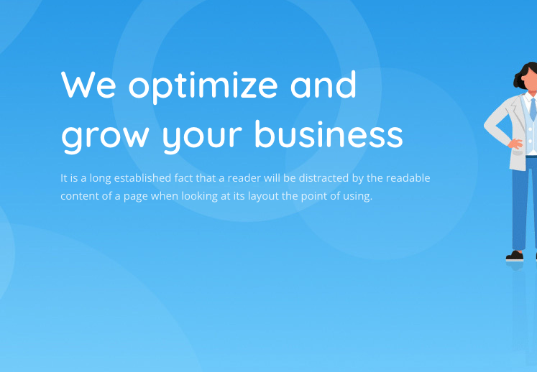
Any Text Changes here ?
We engineer your brand’s digital presence!
An exemplary digital marketing journey for your brand with a fully-fledged digital marketing agency that has a 360 degree wide scope to cover all your needs!
Check out our services - Put an action button here, where if they click the services dropdown to appear and the screen to scroll up if needed.

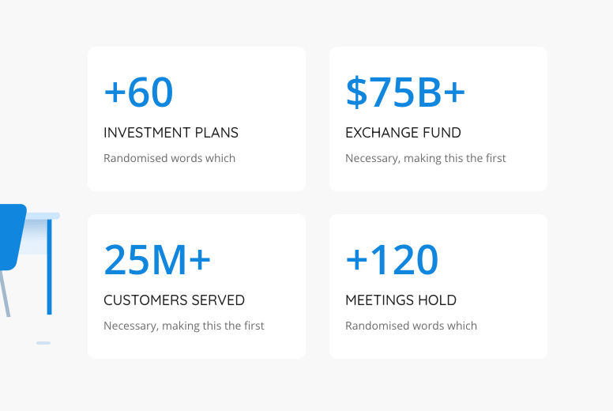
Text for this section

Operating Countries
Countries we currently work with- 6+
Handled Marketing Budgets
Marketing budgets we worked with - LKR 2,000,000+
Deliverable
Digital content delivered - 350+
Team Members
Equipped team members - 35+

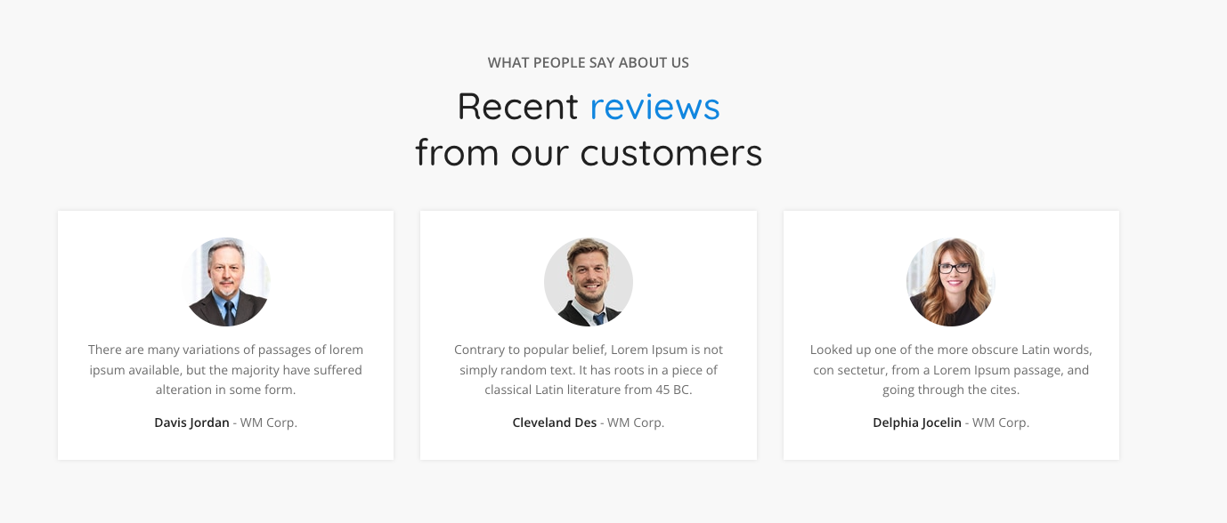
Send 3 testimonials. Fake reviews would do if you dont have anything real for now ;)
prepare a block and keep it hidden :(

https://gallestar.biz/sm/know-us/what-we-do/
Any Logos to upload under our clients ?
Let’s this add as slider on the footer or something in our services pages too. I will add the logos on the drive in a new folder.

Case Study Contents ?
Not for the moment, prepare a block and keep it hidden
https://gallestar.biz/sm/life-at-sparkle-media/
Any photos for the gallery ?
Yes, add anything you like and feel is good. And add more photos of the team here and there like starting slider or something for example.

